Feature image: "Shop bold black diamond necklaces now."
Meta Description:
Looking for a men's black diamond necklace? Learn about diamond quality, metal options, and personalization to find the perfect piece at Crystal Jewelers.

What to Consider When Choosing a Black Diamond Necklace for Men?
When choosing the black diamond necklace for a man, you should consider not only the clothing accessory will look impressive but also meaningful. Black diamond rings have gained people’s attraction and fascination because of the beauty and sophistication they carry.
Here is a guide on the most important factors that will guide you when selecting the best black diamond necklace for men that will be a combination of class and substance.

Know the Appeal of Black Diamonds:
Before you make any decision regarding the selection of black diamonds, first you understand the appeal of black diamonds.
Black diamonds have unique characteristics because they are devoid of any secondary hues.
Additionally, Black diamonds can easily be distinguished from other types of diamonds because they are not associated with brilliance and shine like other diamond colors.
Such a quality makes them suitable for anyone who wants to upgrade their status by making a daring move to stand out from the rest.
Here are some factors that will tell you about the real appeal of the black diamonds:

- Rarity: Black diamonds are not widely available in the market as clear ones, which makes the necklace even more aesthetic and elegant to own.
- Durability: Black diamonds are very hard. This means they can’t be easily scratched and therefore can be used for daily wear.
- Metaphor: Black diamonds perfectly embody the contemporary vision of a strong, powerful, and tender romance that is not deprived of sophistication.

Factors to Consider When Choosing a Black Diamond Necklace for Men
Stop! If you are going to choose a black diamond necklace for men without any research. Here are some factors you should consider before making your choice:

1. Setting and Style:
The setting of the necklace affects the jewelry’s looks and wearability in a big way. You should consider factors like trends and metals in the setting and style.

Men's Necklace trends can be divided into two types which are solitaire and multi-row and the best choice for you can be determined based on your requirements. Multi-row settings give additional glamour and look perfect if used for more conspicuous items.

You can also consider the metal type for the setting. Popular options that you can consider are:
- Platinum: Trendy and does not have any allergens.
- White Gold: Offers a traditional look as compared to platinum. Additionally, it is relatively cheaper than platinum.
- Yellow Gold: Provides a vintage or traditional look because the yellow color contrasts with black diamonds.
- Rose Gold: Adds a romantic, contemporary twist to the piece.

2. Diamond Quality:
The color of the black diamond is one of the most distinct features to be considered apart from the quality. The following factors that define the quality are as follows:

- Cleavage: Plays an important role in deciding the brilliance of the diamond. The cleavage of black diamonds also plays a significant role in increasing the brilliance and fire of the diamond.
- Inclusions: Some natural black diamonds are mined in Brazil and in South Africa, but due to the material’s natural growth process, it has inclusions. Avoid inclusions that are large and anything that may bring down the beauty of the diamond.
- Carat Weight: Decide on the size of the diamond. At least 1-2 carat sizes of stones are wearable during the day but sizes of 3 and above are a show stopper.

3. Design and Customization
Here, there is a possibility to attach some emotions to the necklace which makes it look personal. Consider these design elements:

Messages:
A meaningful message, the initials of the bearer or the birthstone could be engraved on it to add to the uniqueness of the piece.

Necklace Chain:
The chain used to hold the stone should also be matched to the stone. Popular choices include:
- Self-creating Box Chain: It is a classic and masculine type.
- Wide Chain: Offers a modern and bold look.
- Plated Chain: This is recommended for those who do not want to attract much attention to an augmented body part.

Other combinations:
You can also consider other stone options like diamonds, sapphires, or emeralds to try different combinations according to your own taste.

4. Intended Occasion and Wearability
Where and how the necklace will be used has to be put into consideration.

- Categorize: According to usability, you should categorize different types based on continuously worn, durability and comfort. There is always the possibility that you will need to dress up for an occasion formal or semi-formal event, then it is advisable that you take your time and get a better design.
- Functionality: Make sure the necklace is not too large for the worn and is not too heavy for anyone who might use it.

5. Budget Considerations
Black diamonds have a relatively low price but it depends on size and the type of metal that is used to set the precious stone. It is best to set a budget up from the beginning of the search process to eliminate certain options.
You can also consider the options of instant financing or monthly installments offered by the jewelers.

Where to Buy Your Favorite Men's Black Diamond Necklace?
Crystal Jewelers serves as your reliable destination to acquire the perfect necklaces for men with black diamonds.
Our specialists will always assist you through decision-making by offering expert guidance and a comprehensive selection of top-quality products.
Here are the various factors that demonstrate Crystal Jewelers represents a sound choice for jewelry purchases.
- Quality Control: Every single piece that we sell undergoes a quality check to conform to quality and stylish standards.
- Warranty and Return Policy: Enjoy peace of mind with our generous warranty and hassle-free return policy.
- Customer Care: Our care for customers begins from the point of consultation to the offer to purchase a product.

Additional Tips:
- Fit Check: It is wise to have the necklace worn for a while to determine if the wearer is comfortable with the style of the piece.
- Get Inspiration: Collect pictures from fashion magazines and galleries and the current trends that you like.

Ending Note:
Selecting the best black diamond necklace for a man requires a lot of factors to be taken into consideration including the design of the necklace, the cut and the kind of diamond that has been used, and the purpose you intend to put the necklace into.
For any person who would want to buy a necklace for any special occasion, or third person, or even for themselves, a black diamond necklace is a symbol of contemporary taste and style.
You can rely on Crystal Jewelers to order the best men’s black necklace that suits your needs.
Start your search with the surety that any piece you purchase from Crystal Jewelers is a piece that exudes the beauty of black diamonds and the beauty of you as a person.
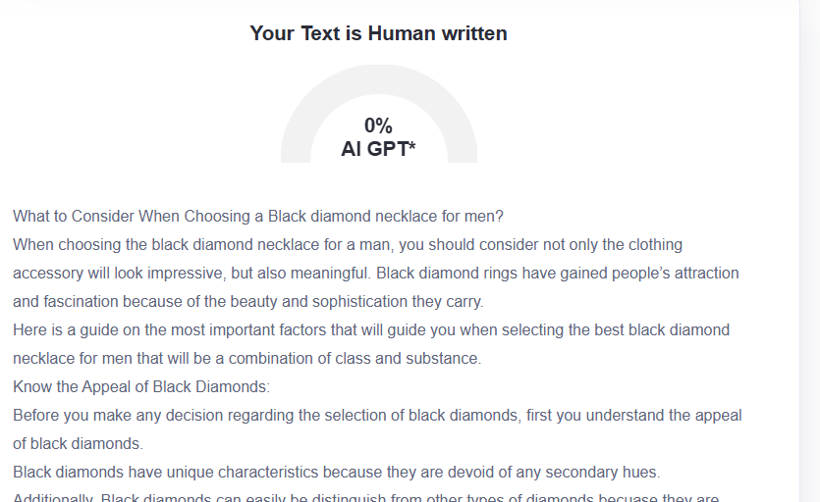

GMB
Searching for the perfect black diamond necklace for men? Crystal Jewelers offers essential guidance for selecting this distinguished accessory. The distinct characteristics of black diamonds consist of their scarcity as well as their durability with modern masculine style alongside traditional diamond brilliance absence. Your choice should involve the evaluation of both solitaire or multi-row setting formats along with metal selection between platinum, white gold, yellow gold and rose gold. Each diamond possesses three evaluation criteria to determine its quality, which are cleavage and inclusions and carat weight, and customers choose between personalized engravings and additional chain designs during their purchase. Personal and functional design along with comfortable usability remain essential factors during all types of wear. Specialists at our company help you with the identification before making any choice. Our jewelry store supports its jewelry collection with extensive warranties and an easy return process. The black diamond necklace available at Crystal Jewelers offers more than modern style because it delivers exceptional workmanship, which boosts your individual look. Get your dream men's black diamond necklaces at Crystal Jewelers where elegance meets durability alongside our dedication to exceptional quality and total customer satisfaction.

